# JMC & ONWA User Data Import

2015-10-15

# Prepare Work

Note1: The following steps are tested on JMC (V-6810P) and ONWA( KP636).

If you are using other serial products, we cannot make sure it work well.

Note2: To preserve a good compatibility with JMC & ONWA device, please make sure you have upgraded Aquamap to **Version 2. 80 or greater**. We strongly suggest to **backup current user data to SD card** first, in case of unpredicted situations.

# Data Transfer

Step1 : Connect Aquamap NMEA port1 to JMC / ONWA, suggest to get the ground terminal together to reduce noise (Please refer to the appendix picture ).

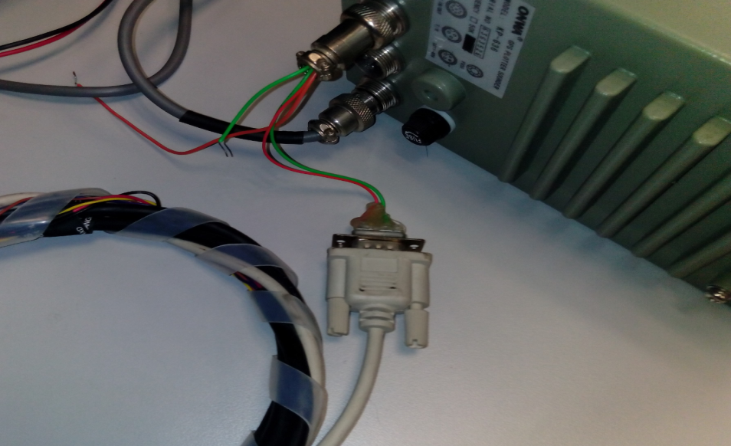

Step2: Set Aquamap : NMEA0183 port and select the correct baud rate

**Home –> Settings -> Communications -> Serial Port 1/2 -> NMEA Standard (4800bps )**

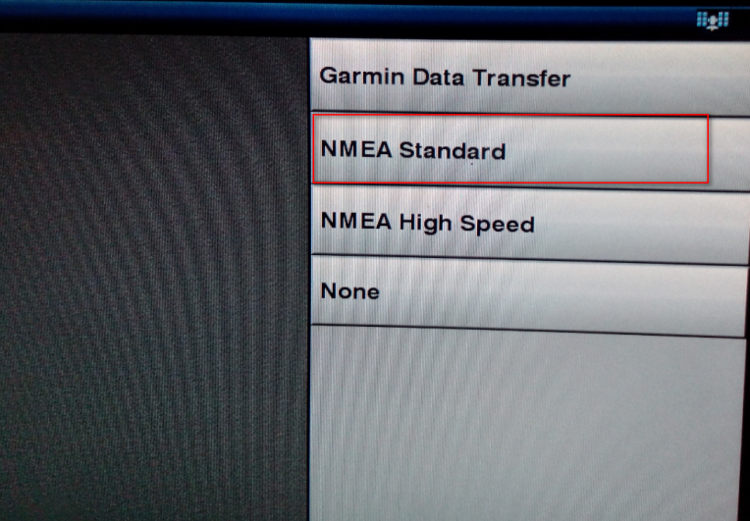

Step3: Set JMC or ONWA: Hold "**Erase"** + **"Nav"** combo button to enter below page and select the data type that you want to export .

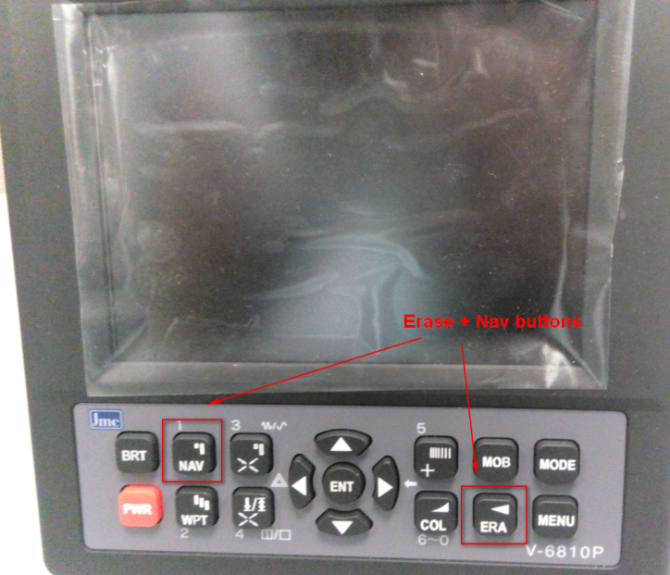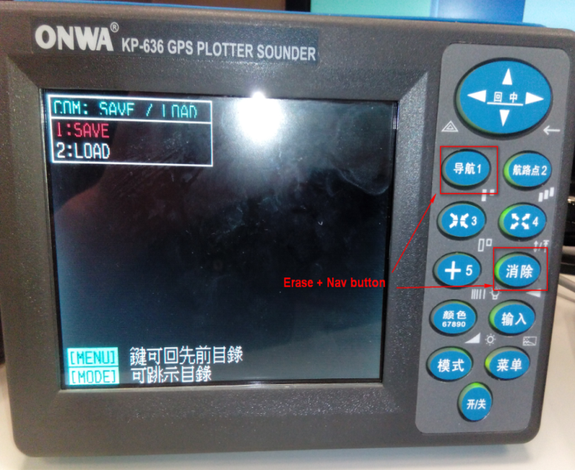

**ONWA Layout JMC Layout**

Step4: JMC or ONWA: Choose the data type, Such as WPT or BOUNDARY, **double click "Enter"** button to start data transmit procedure.

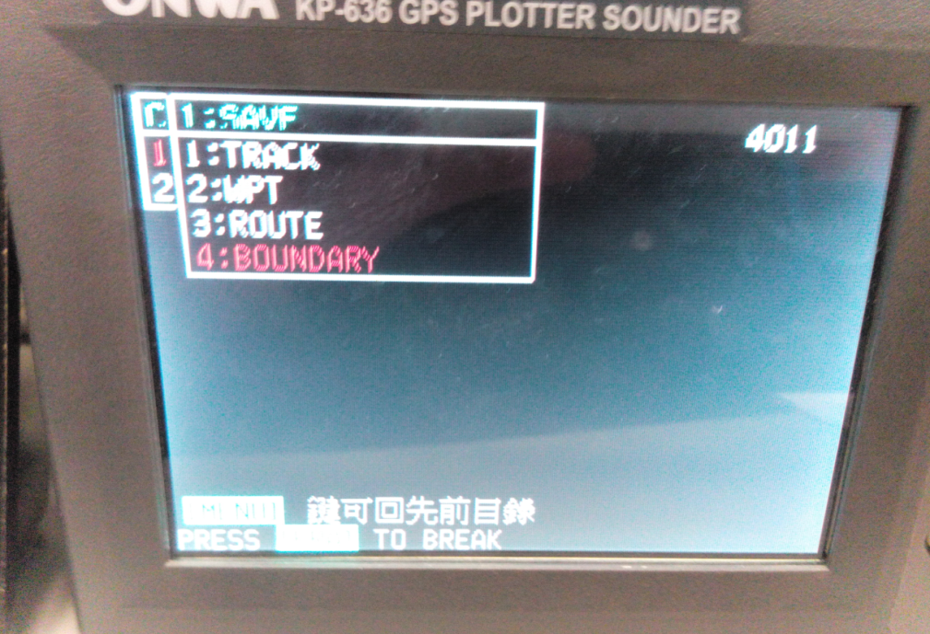

Step5: Check the user data on Aquamap after transfer finish.

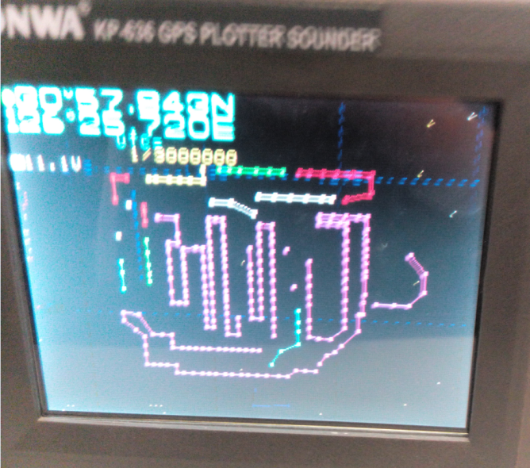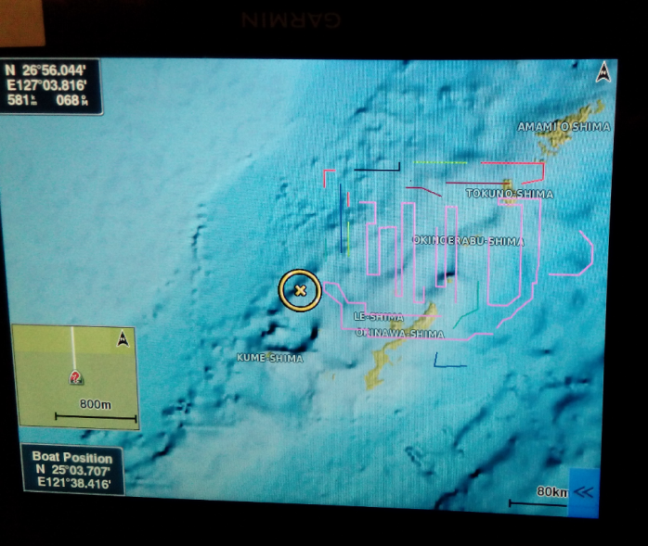

Note:

Due to the different system color scheme, the boundary data won’t lead to be the same as the original color. Anyway, you can refer to below map table for comparison.

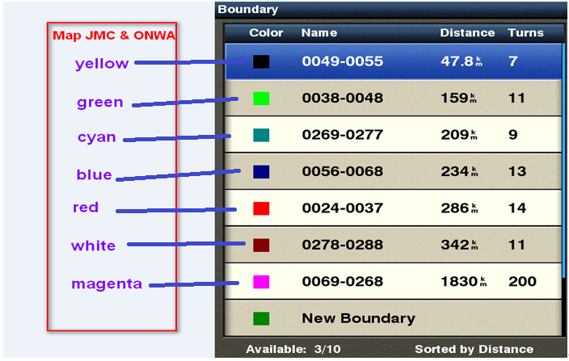

For some special case, if you have some problems during the import process, please try below methods

* Check the NMEA0183 cable and connect to PC, ensure it is avalible.
* Disable all input data in NMEA0183 port on Aquamap

**Home –> Settings -> Communications ->NMEA 0183 Setup ->** Turn nmea sentence off

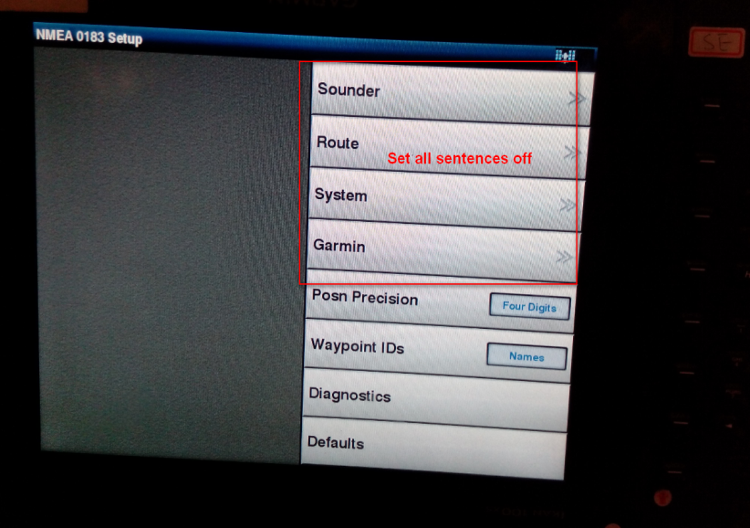

* Restart the data transfer procedure, but it’s recommended to clear imported data before.

**Home –> Nav Info -> Manage Data ->Clear User Data->** Select a data type

# Appendix

--- JMC & ONWA NMEA0183 Port Layout

